Lab 3 Newton’s Laws PHY250L

**Student Name:** Harshan Atwal

**Access Code (located on the underside of the lid of your lab kit):** AC-8C7GM34

**Pre-Lab Questions”**

Use the free body diagram of the pulley (Figure 4) to answer the Pre-Lab Questions.

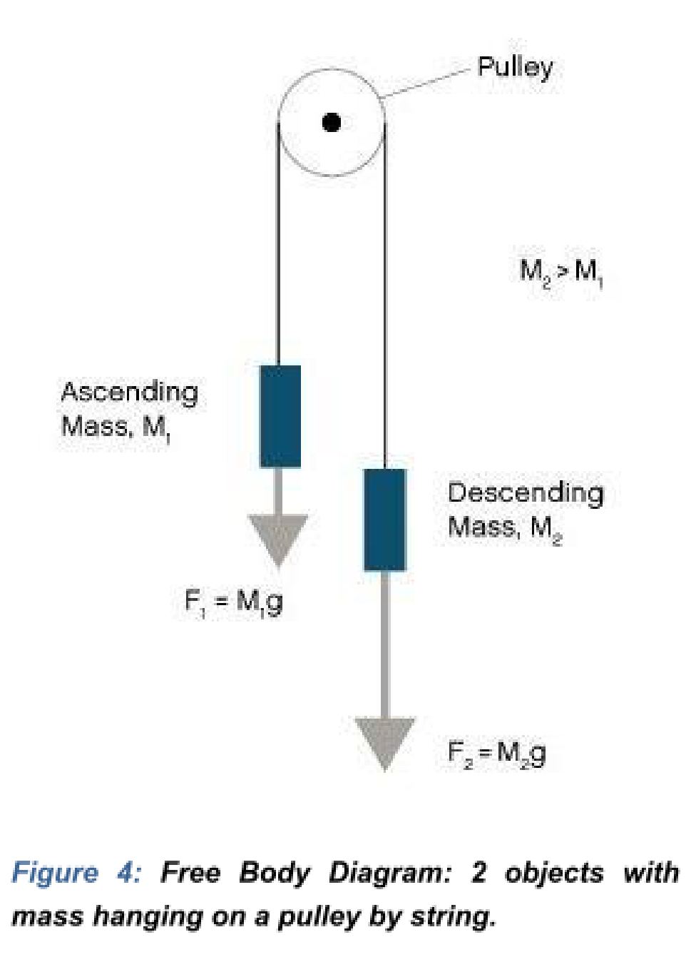

|  |  |
| --- | --- |
| 1. | Draw a free body diagram for M1. Handwrite your name next to your diagram. |



Lab 3 Newton’s Laws PHY250L

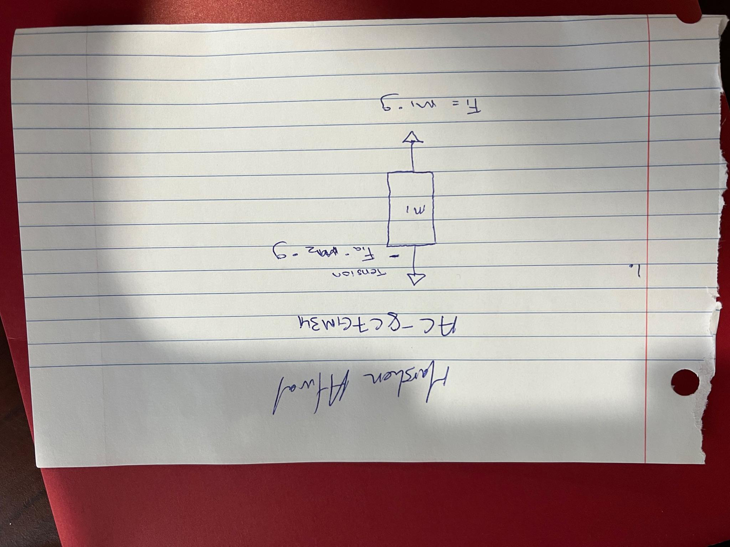

2. Draw a free body diagram for M2. Handwrite your name next to your diagram.

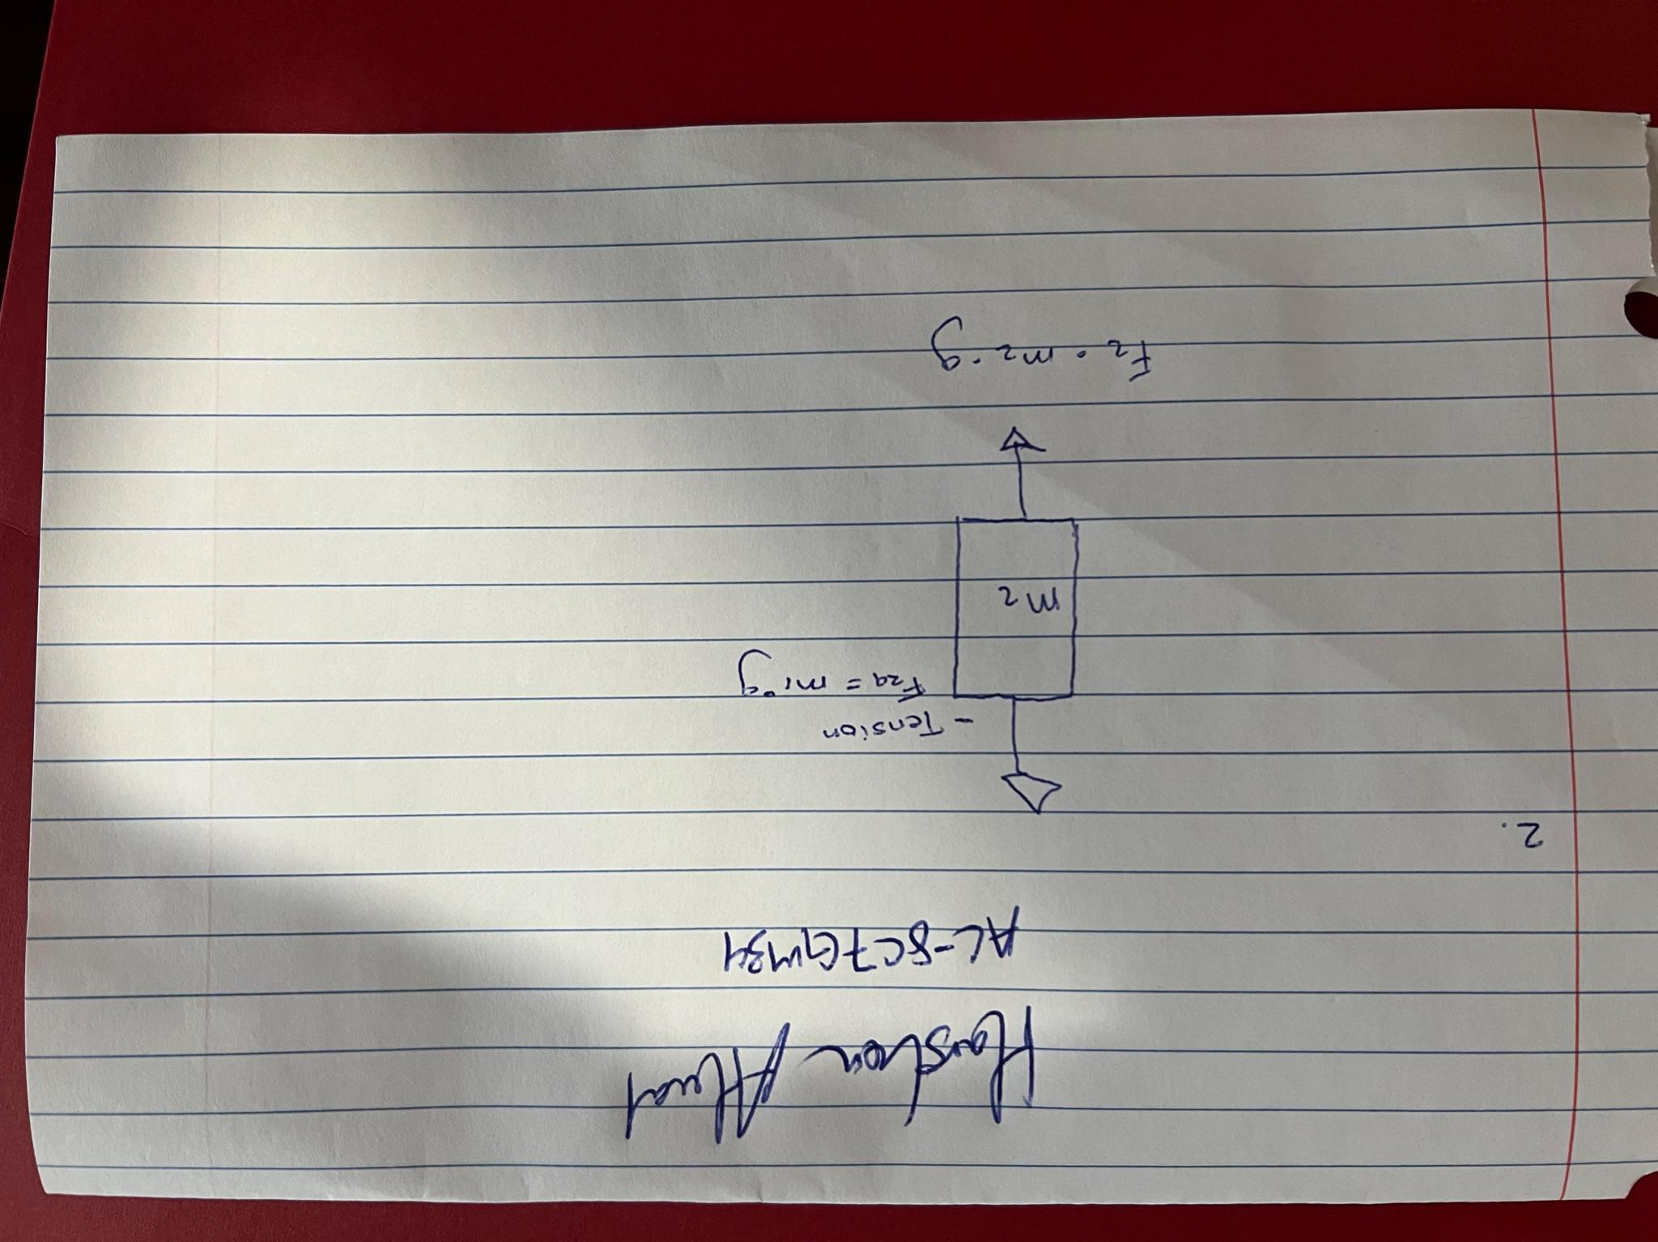



|  |  |  |
| --- | --- | --- |
| Lab 3 Newton’s Laws | | PHY250L |
| 3. | Apply Newton’s 2ndLaw to write the equations for M1 and M2. You should get two equations | |

with Tension in the string, weight for each mass and accelerations for each mass (a1 and a2). For M1: Tension - M1*g = M1*a1 For M2: M2*g - Tension = M2*a2

4. This results in two equations with three unknowns! A third equation is required to solve the

system. What is the third equation? (Hint: What is the relationship between a1 and a2?) The third equation is M2*g - Tension = -M1*a1

**EXPERIMENT 1: NEWTON’S FIRST LAW OF MOTION**

Data Table   
 **Table 1. Motion of Water Observations**

|  |  |
| --- | --- |
| **Motion** | **Observations** |
| **a** | water splashed out |
| **b** | water moved but did not spill |
| **c** | water spilled left when turning right and spilled right when turning left |
| **d** | water first spilled forward then back at me |

**Table 2. Observations after Flicking Notecard Off of Cup**

|  |  |
| --- | --- |
| **Trial** | **Observations** |
| **1** | card and coin both fell away |
| **2** | coin fell into cup and card fell away |
| **3** | coin and card both fell away |



|  |  |
| --- | --- |
| Lab 3 Newton’s Laws | PHY250L |

|  |  |
| --- | --- |
| **4** | coin fell into cup and card fell away |
| **5** | coin fell into cup and card shifted to side of cup |

**Post-Lab Questions**

1. Explain how your observations of the water and washer demonstrate Newton’s law of inertia. In the case of the water and washer, when an external force was applied, due to inertia, the water stayed at rest and spilled side to side and front and back.

|  |  |
| --- | --- |
| 2. | Draw a free body diagram of your containers of water from the situation in Part 1 Step 4d. |

Draw arrows for the force of gravity, the normal force (your hand pushing up on the container), and the stopping force (your hand accelerating the container as you stop.) What is the direction of the water’s acceleration?

The direction of water was towards me

Handwrite your name next to your diagram.



Lab 3 Newton’s Laws PHY250L

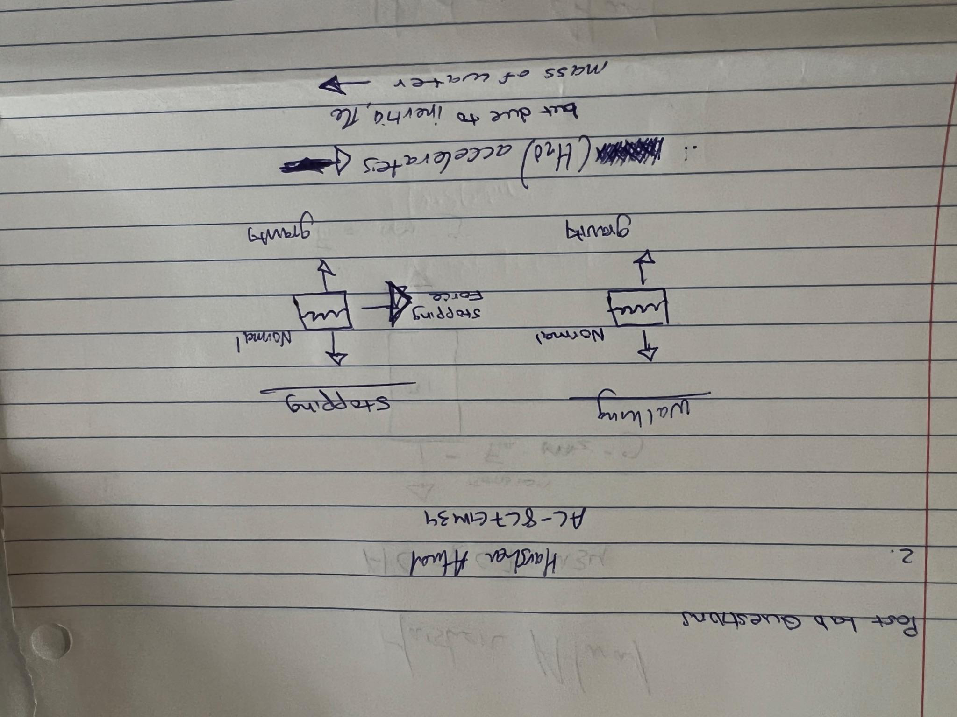

|  |  |
| --- | --- |
| 3. | Can you think of any instances when you are driving or riding a car that are similar to this |

experiment? Describe two instances where you feel forces in a car in terms of inertia. Two situations where you feels forces in a car regarding inertia are during sudden braking, which causes one to thrust forward, and during sudden acceleration, where one is thrust back into the seat.



Lab 3 Newton’s Laws PHY250L

**EXPERIMENT 2: NEWTON’S THIRD LAW AND FORCE PAIRS**

Data Table

**Table 3. Forces on a Stationary Spring**

|  |
| --- |
| **Force on Stationary 10 N Spring Scale (N)** |
| 5.5N |
| **Force on Stationary 5N Spring Scale (N)** |
| 5N |

**Table 4. Spring Scale Force Data**

|  |  |  |
| --- | --- | --- |
| **Suspension Set Up** | **Force (N) on 10 N Spring Scale** | **Force (N) on 5 N Spring Scale** |
| **0.5 kg Mass on 10 N Spring Scale** | 5N |  |
| **0.5 kg Mass with String on 10 N Spring Scale** | 5.3N |  |
| **0.5 kg mass, string and 5 N Spring Scale on 10 N**  **spring scale** | 5.5N | 5N |
| **0.5 kg mass, string and 5 N Spring Scale on 10 N**  **spring scale on Pulley** | 6.2N | 5N |

**Post-Lab Questions**

1. How did the magnitude of the forces on both spring scales compare after you moved the 10



Lab 3 Newton’s Laws PHY250L

N spring scale?

magnitude forces of both scales are equal

|  |  |
| --- | --- |
| 2. | How did the magnitude of the forces on both spring scales compare after you move the 5 N |

spring scale?

Both will read at 5N

|  |  |
| --- | --- |
| 3. | Use Newton’s 3rd Law to explain your observations in Questions 1 and 2. |

Newton's Third Law states that for every action, there is an equal and opposite reaction; therefore, when we pull one scale by 5N, the other scale will exert the same amount in the opposite direction.

|  |  |
| --- | --- |
| 4. | Compare the force on the 10 N spring scale when it was directly attached to the 0.5 kg mass |

and when there was a string between them.

it was slightly greater with the string than when it was directly attached



|  |  |  |
| --- | --- | --- |
| Lab 3 Newton’s Laws | | PHY250L |
| 5. | Compare the force on the two spring scales in Steps 5 and 6. What can you conclude about | |

the tension in a string?

In Step 5, the force applied to each spring scale was equal to the 5 N string tension. Then due to the increased string tension in Step 6, the force on the 10 N spring scale increased while the force on the 5 N spring scale dropped. This shows that if the string has no mass and doesn’t stretch out, the tension is constant throughout the entire string.

**Take a photo of your pulley, spring scales, and 0.5kg mass setup (should look like Figure 6) . Be sure to have your name handwritten in the background of the photo.**

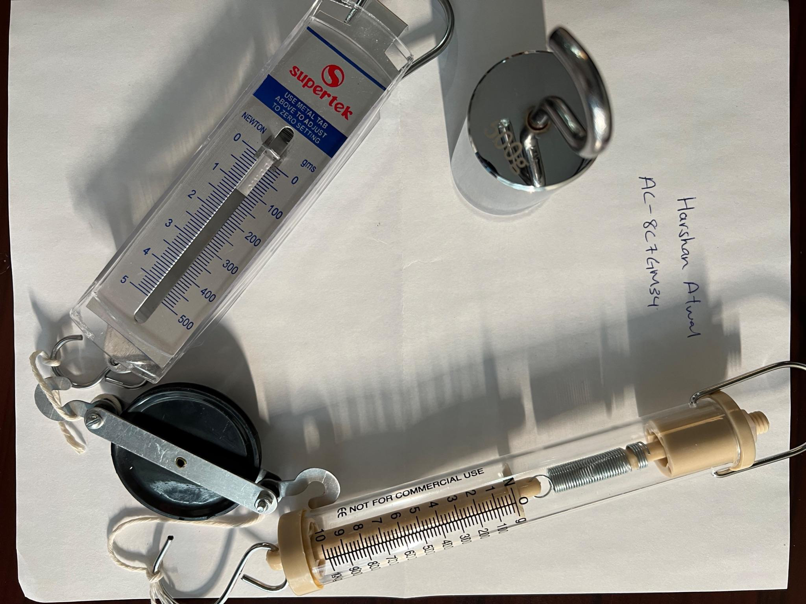



Lab 3 Newton’s Laws PHY250L

**EXPERIMENT 3: NEWTON’S SECOND LAW AND THE ATWOOD**

Data Table

**Table 5. Motion Data**

|  |  |  |  |
| --- | --- | --- | --- |
| **Mass of 15**  **Washers (kg)** | 0.06kg | **Average Mass of Washer (kg)** | 0.004kg |
| **Procedure 1** | | | |
| **Height (m):** 1.25m | | | |
| **Trial** | | **Time (s)** | |
| **1** | | 3.62s | |
| **2** | | 3.70s | |
| **3** | | 3.55s | |
| **4** | | 3.82s | |
| **5** | | 3.65s | |
| **Average** | | 3.67s | |
| **Average Acceleration (m/s2)** | | **0.34m/s^2** | |
| **Procedure 2** | | | |
| **Height (m):** 1.45m | | | |
| **Trial** | | **Time (s)** | |
| **1** | | 1.30s | |
| **2** | | 1.15s | |



|  |  |
| --- | --- |
| Lab 3 Newton’s Laws | PHY250L |

|  |  |
| --- | --- |
| **3** | 1.10s |
| **4** | 1.20s |
| **5** | 1.20s |
| **Average** | 1.19s |
| **Average Acceleration (m/s2)** | **0.82m/s^2** |

**Post-Lab Questions**

1. When you give one set of washers a downward push, does it move as easily as the other set? Does it stop before it reaches the floor? How do you explain this behavior?

The washers push back on the hand with an equal and opposite force, this makes it harder to move the set that is pushed downward. It stops before it reaches the floor because of gravity and friction.

|  |  |
| --- | --- |
| 2. | Draw a free body diagram for M1 and M2 in each procedure (Procedure 1 and Procedure 2). |

Draw force arrows for the force due to gravity acting on both masses (Fg1 and Fg2) and the force of tension (FT). Also draw arrows indicating the direction of acceleration, *a*.



|  |  |
| --- | --- |
| Lab 3 Newton’s Laws | PHY250L |

Handwrite your name next to your diagram.

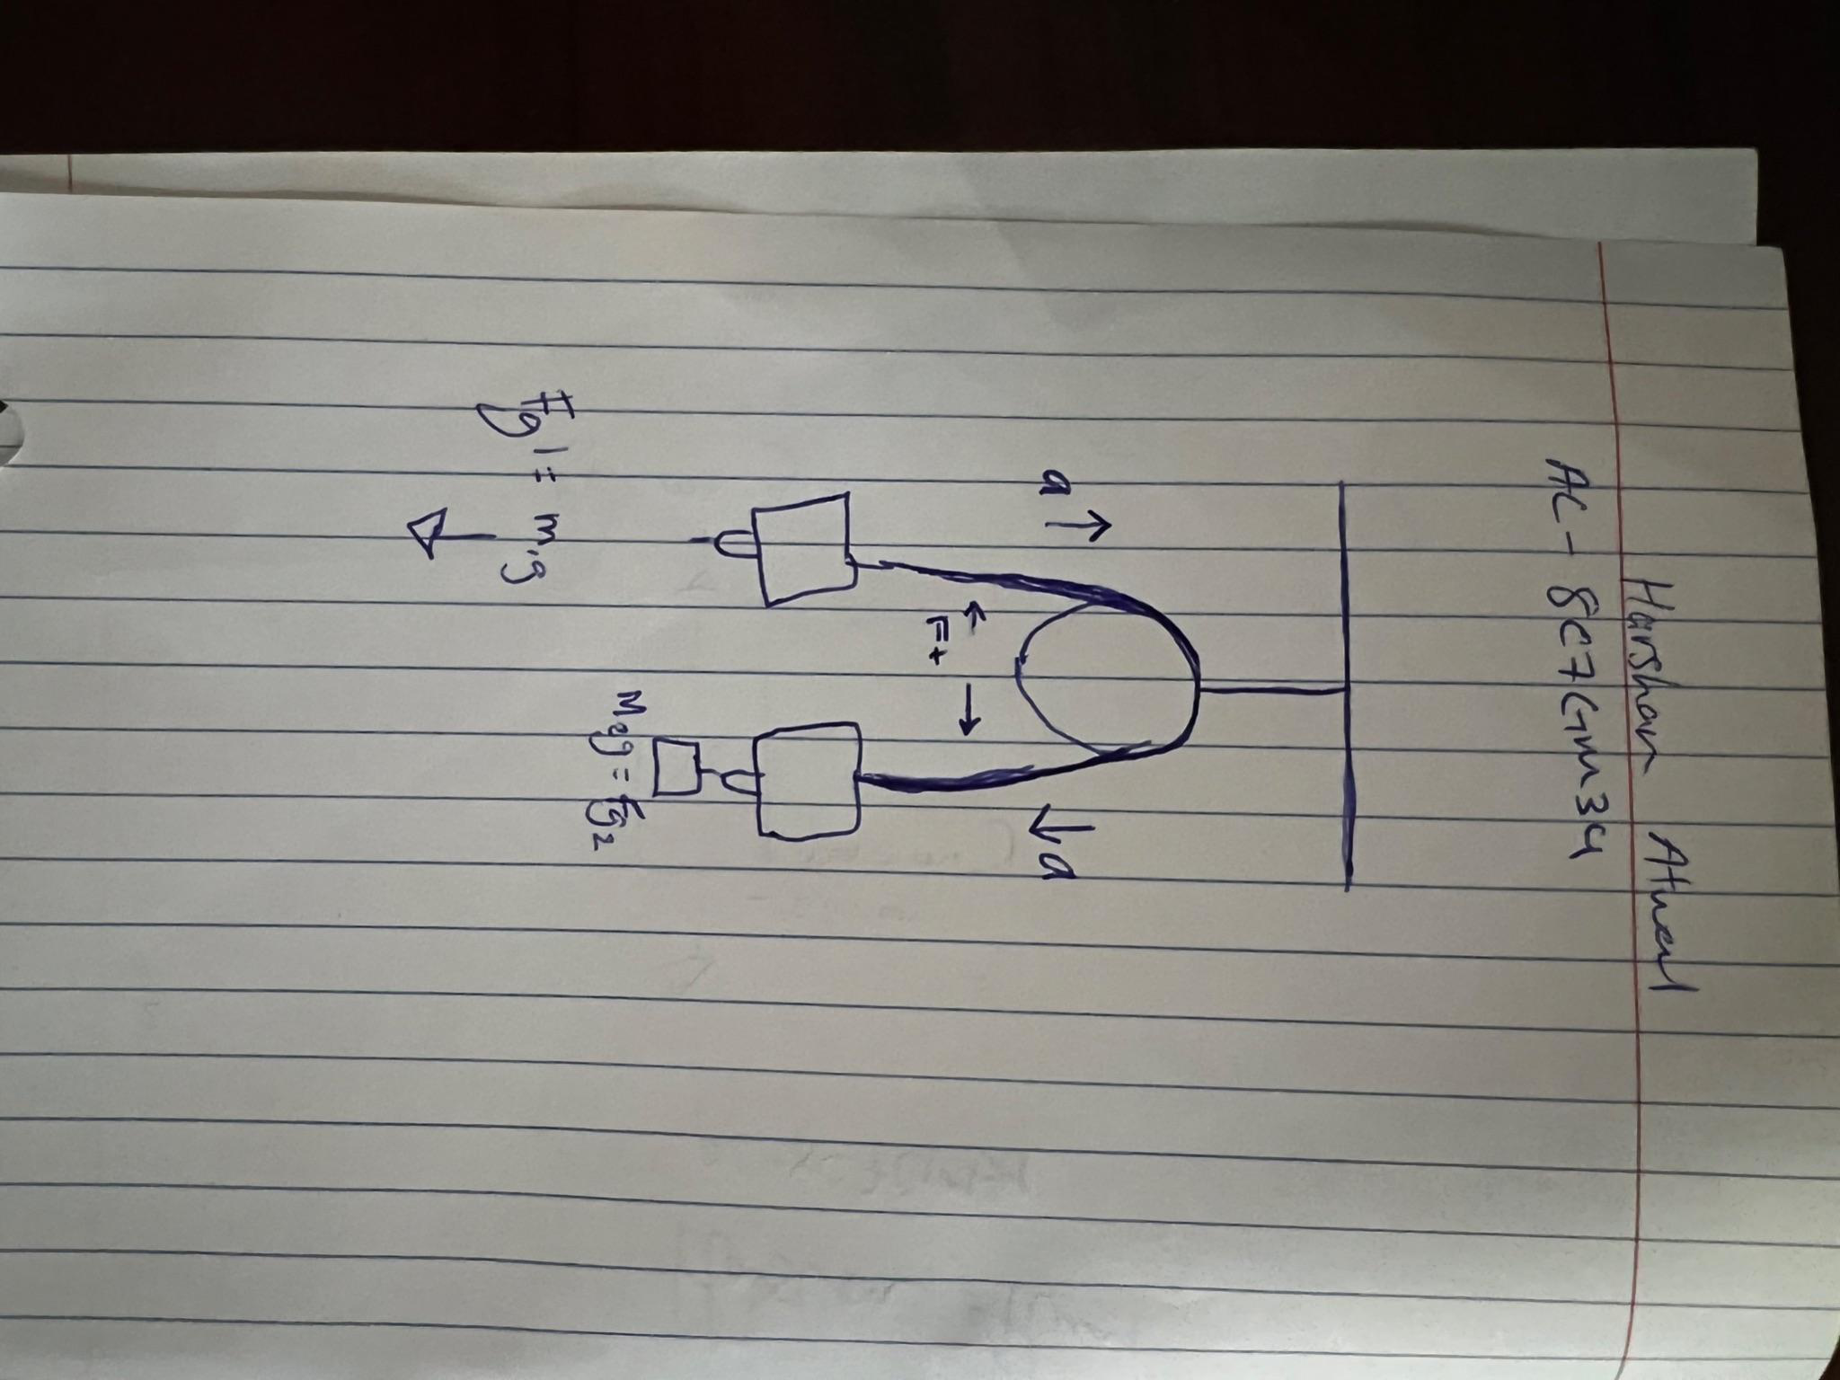

3. Use Newton’s Second Law to write an equation for each of the free body diagrams you drew in Question 2. (Note: Be sure to use the correct signs to agree with your drawings). Solve these four equations for the force of tension (FT). You answer should be in variable form.



|  |  |  |  |
| --- | --- | --- | --- |
| Lab 3 Newton’s Laws | | | PHY250L |
| FT2= m2g - m2a | | FT1= m1g + m1a | |
| 4. | Set the two resulting expressions for the force of tension equal to one another (as long as | | |

the string does not stretch, the magnitude of the acceleration in each equation is the same). Replace Fg1 and Fg2 with M1 and M2, respectively. Solve the resulting equation for *a*. Then, go back to Question 3 and solve for the FT.

|  |  |
| --- | --- |
| m2g - m2a = m1g + m1a | (m2 -m1)g = (m1+m2)a |

a= (m2-m1)g / m1 + m2

|  |  |
| --- | --- |
| 5. | Calculate the acceleration for the two sets of data you recorded and compare these values |

to those obtained by measuring distance and time using percent error. What factors may cause discrepancies between the two values?

Set 1 Percent error: |(0.38 - 0.34) / 0.34| x 100% = 11.76%

Set 2 Percent error: |(0.79 - 0.82) / 0.82| x 100% = 3.66%

The discrepancies are caused by measurement and timing errors.

6. Calculate the tension in the string for the falling washers. From these two values, and the one where the masses were equal, what trend do you observe in the tension in the string as the acceleration increases?



Lab 3 Newton’s Laws PHY250L

The tension in the string will grow as the system's acceleration increases. This is due to the

string's tension having to be strong enough to accelerate both masses in the same direction.

